**NGUYEN NAM KHANH – HE191159 – IA1902 – IAM302**

**LAB 9: Using Jasmin to run x86 Assembly Code**

Storing Results in Memory

* EAX = 4
* EBX = 6
* ECX = 10
* Memory location 0x4 contains 6
* Memory location 0x8 contains 10

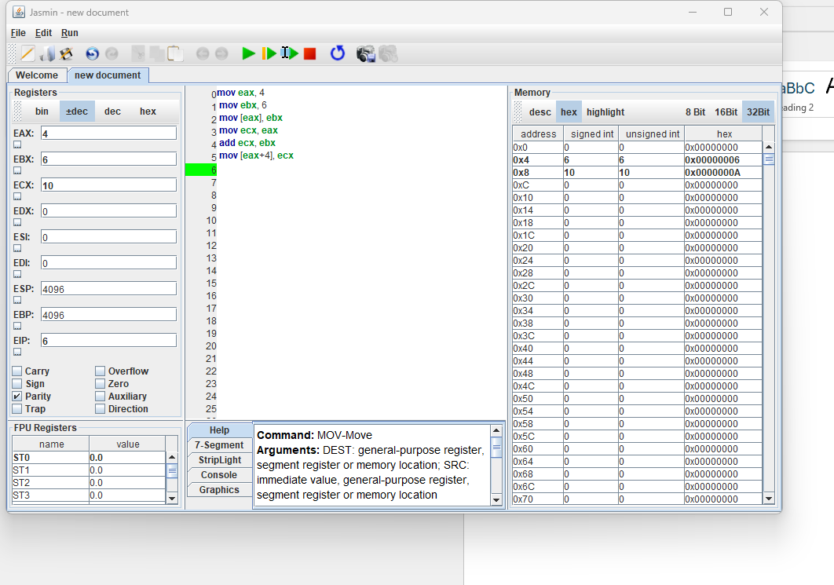

Understanding Push

* EAX contains 4
* EBX contains 6
* ESP contains 4088, which is 0xFF8, the new top of the stack.
* Memory location 0xFFC contains 4, the first value pushed onto the stack.
* Memory location 0xFF8 contains 6, the second value pushed onto the stack.

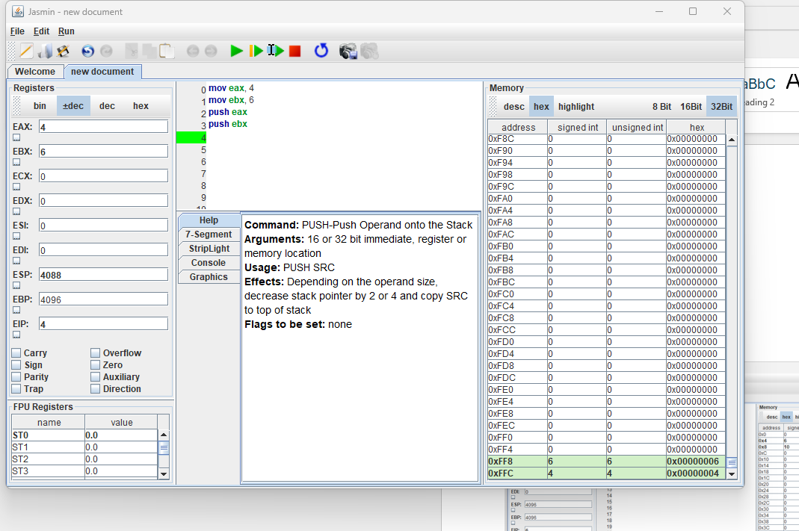

Understanding Pop

* ECX contains 6, the value popped off the top of the stack.
* ESP contains 4092, which is 0xFFC, the new top of the stack.
* Memory location 0xFFC contains 4, the first value pushed onto the stack.
* Memory location 0xFF8 contains 6, which is now the top value on the stack.

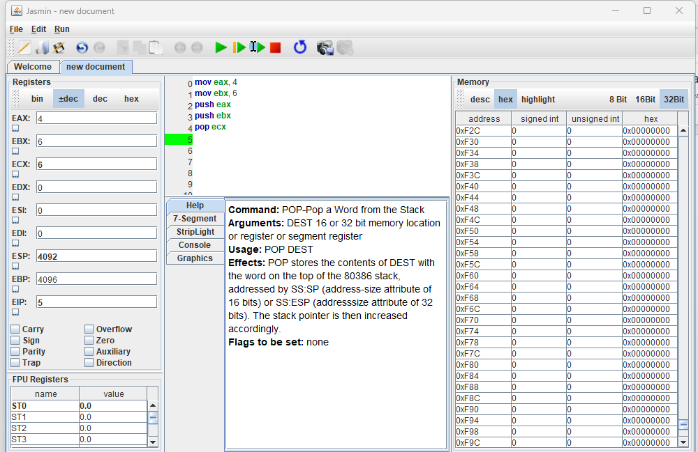

Reversing a Sequence

EAX = 4 EBX = 3 ECX = 2 EDX = 1

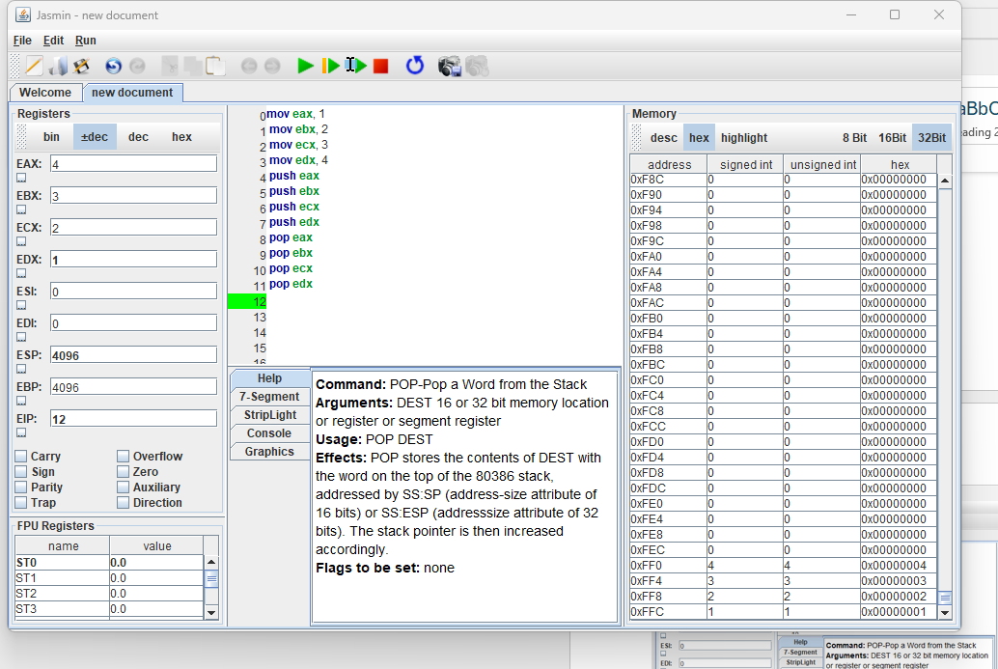

**LAB 9.1: Lab05-01.dll in IDA Pro**

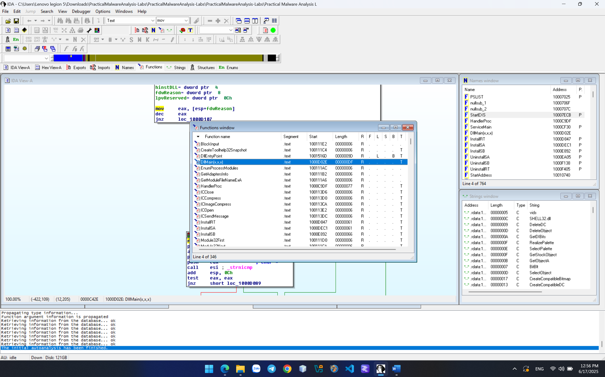

Find the import for gethostbyname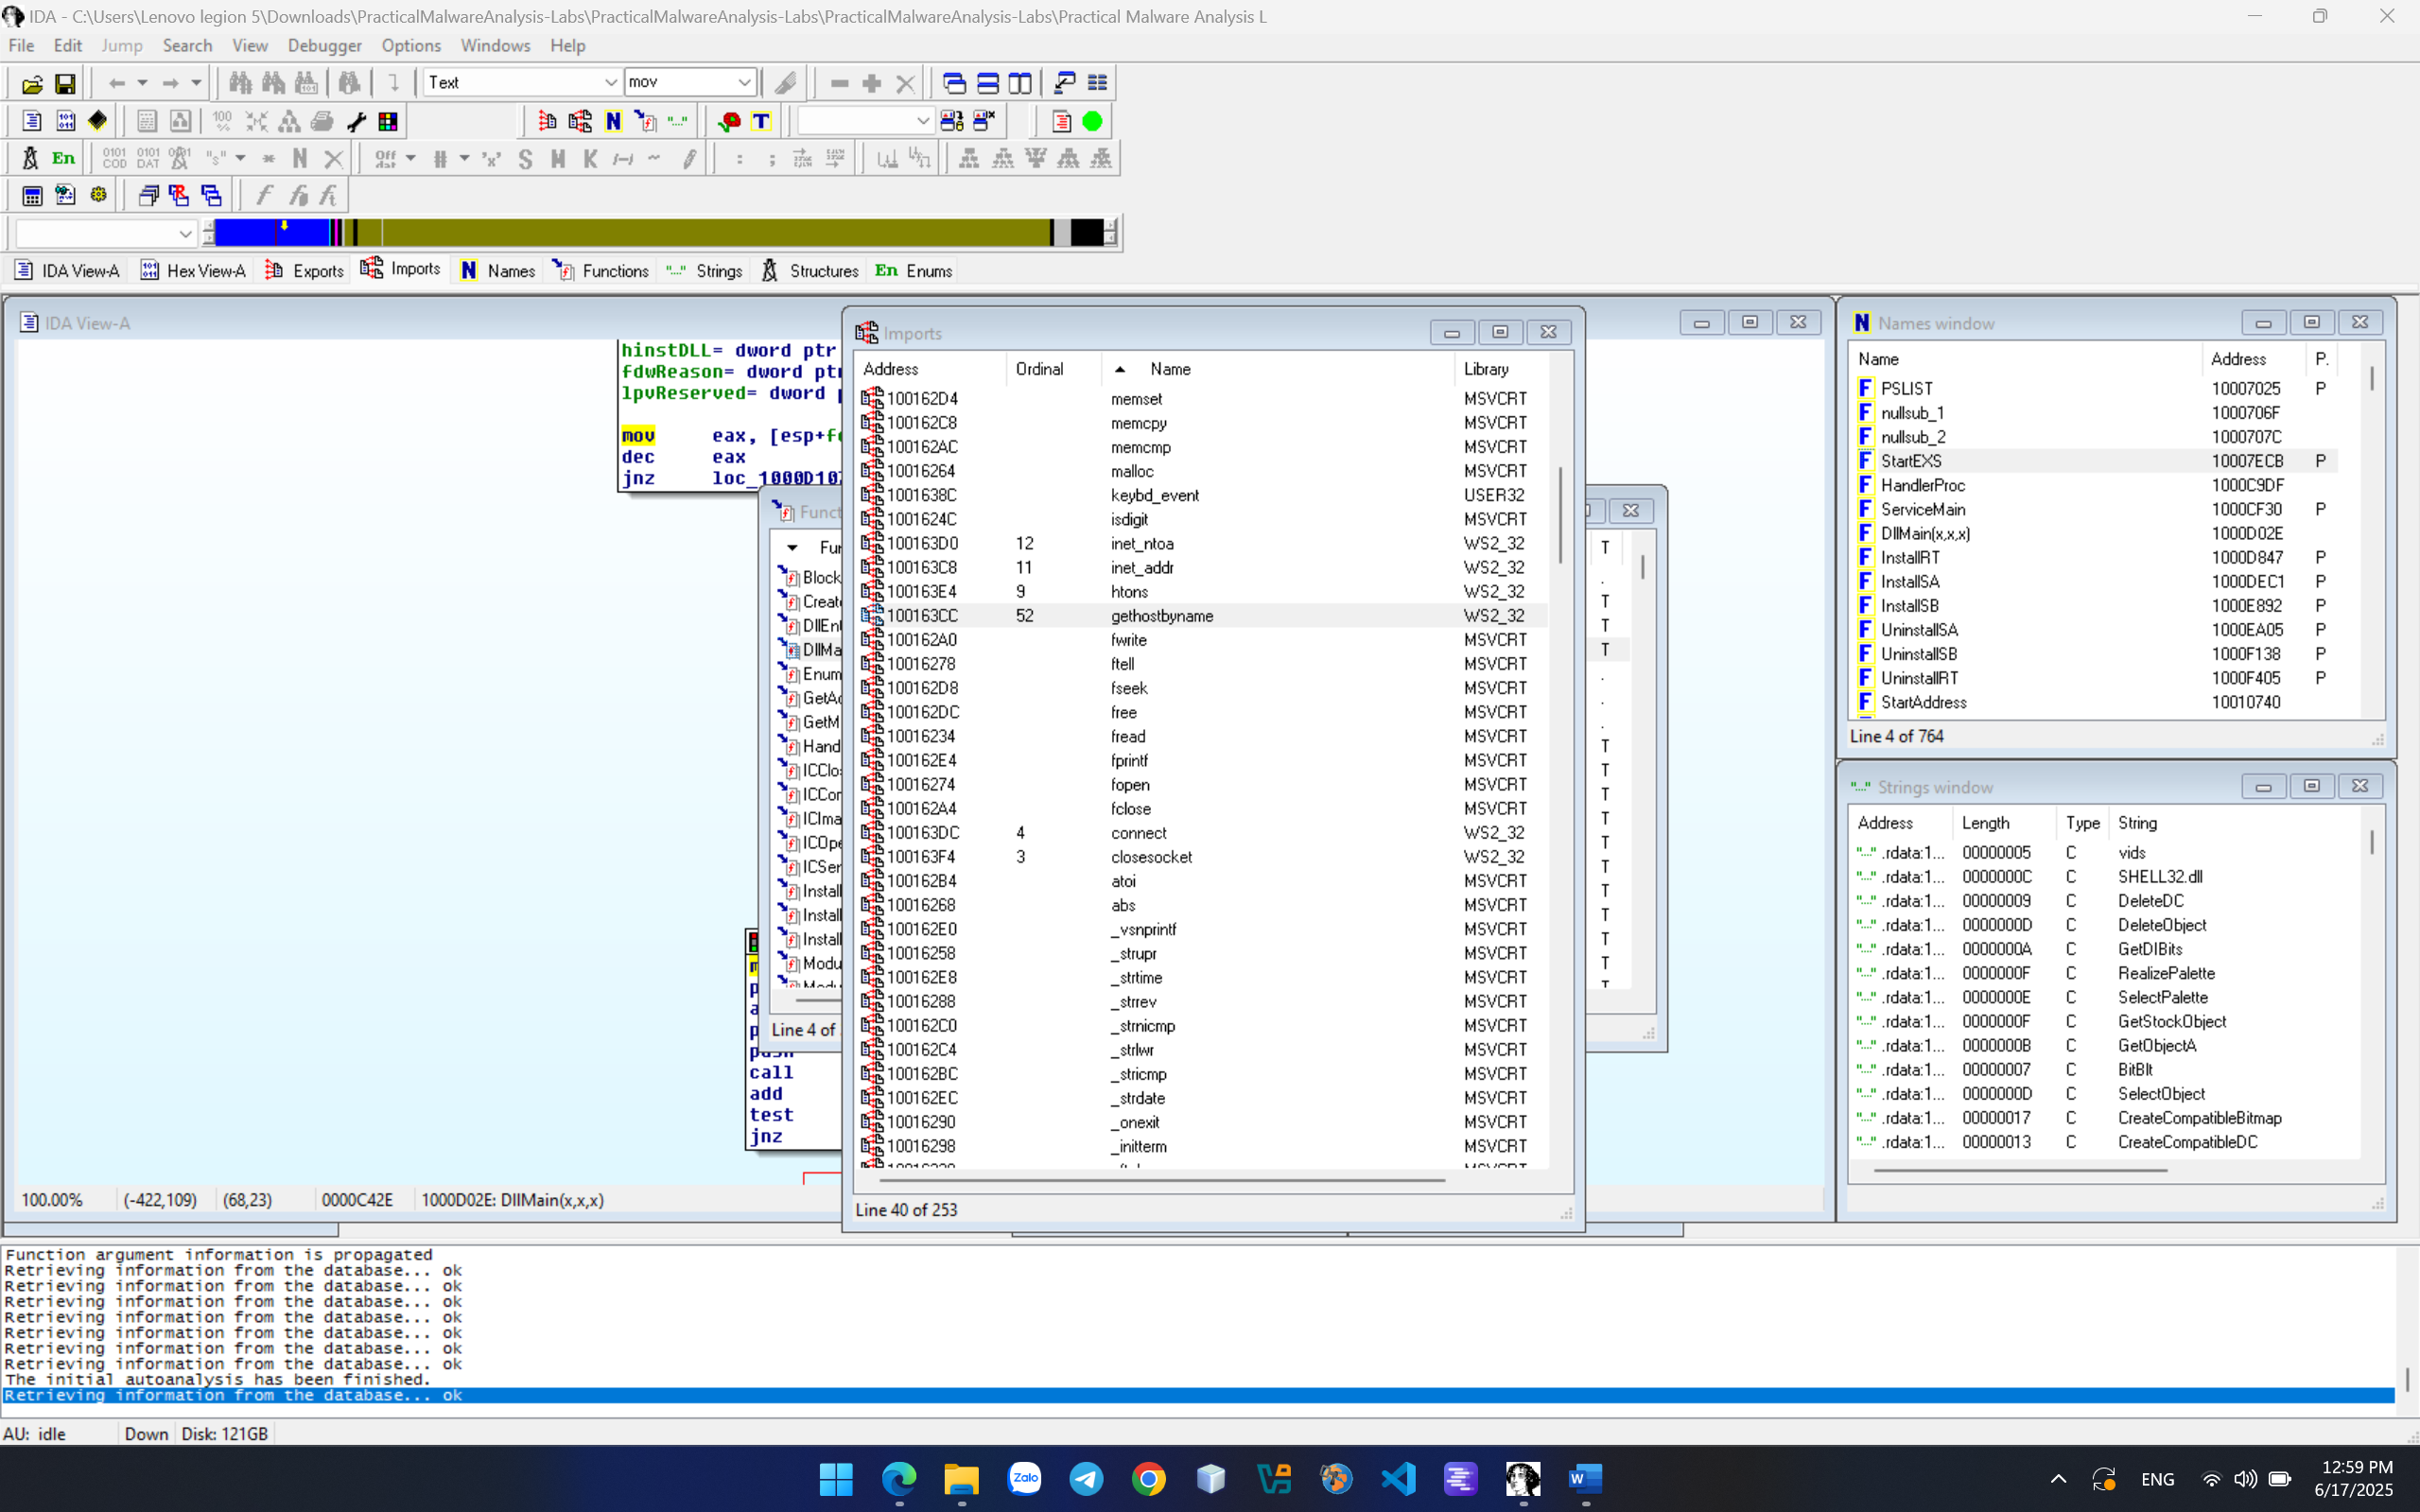

Count Local Variables for the Subroutine at 0x10001656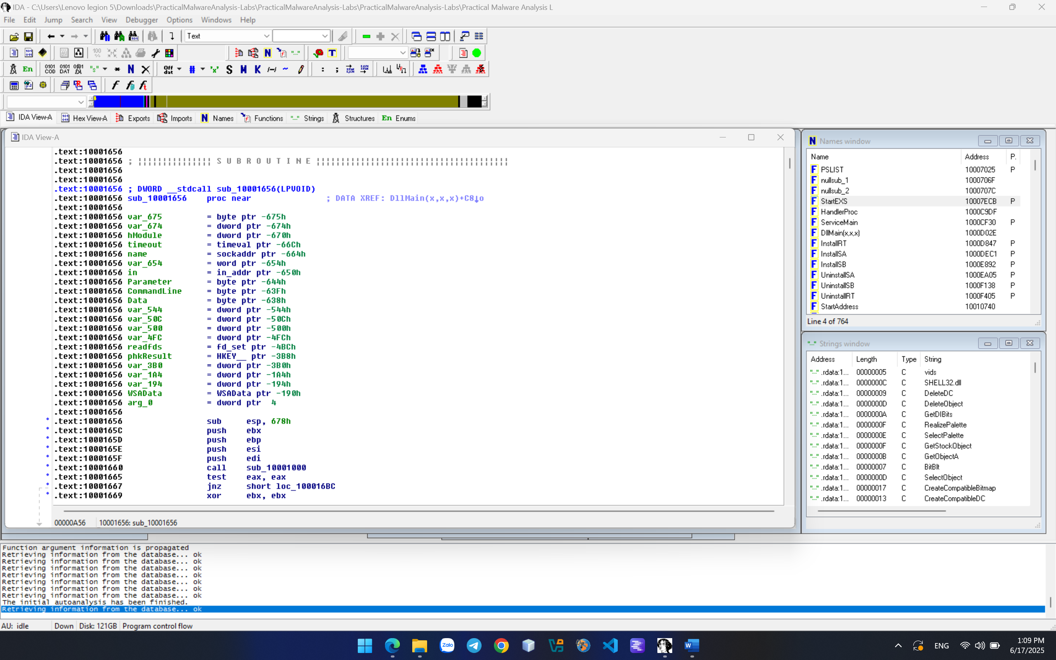

Finding the Purpose of the Code that References \cmd.exe /c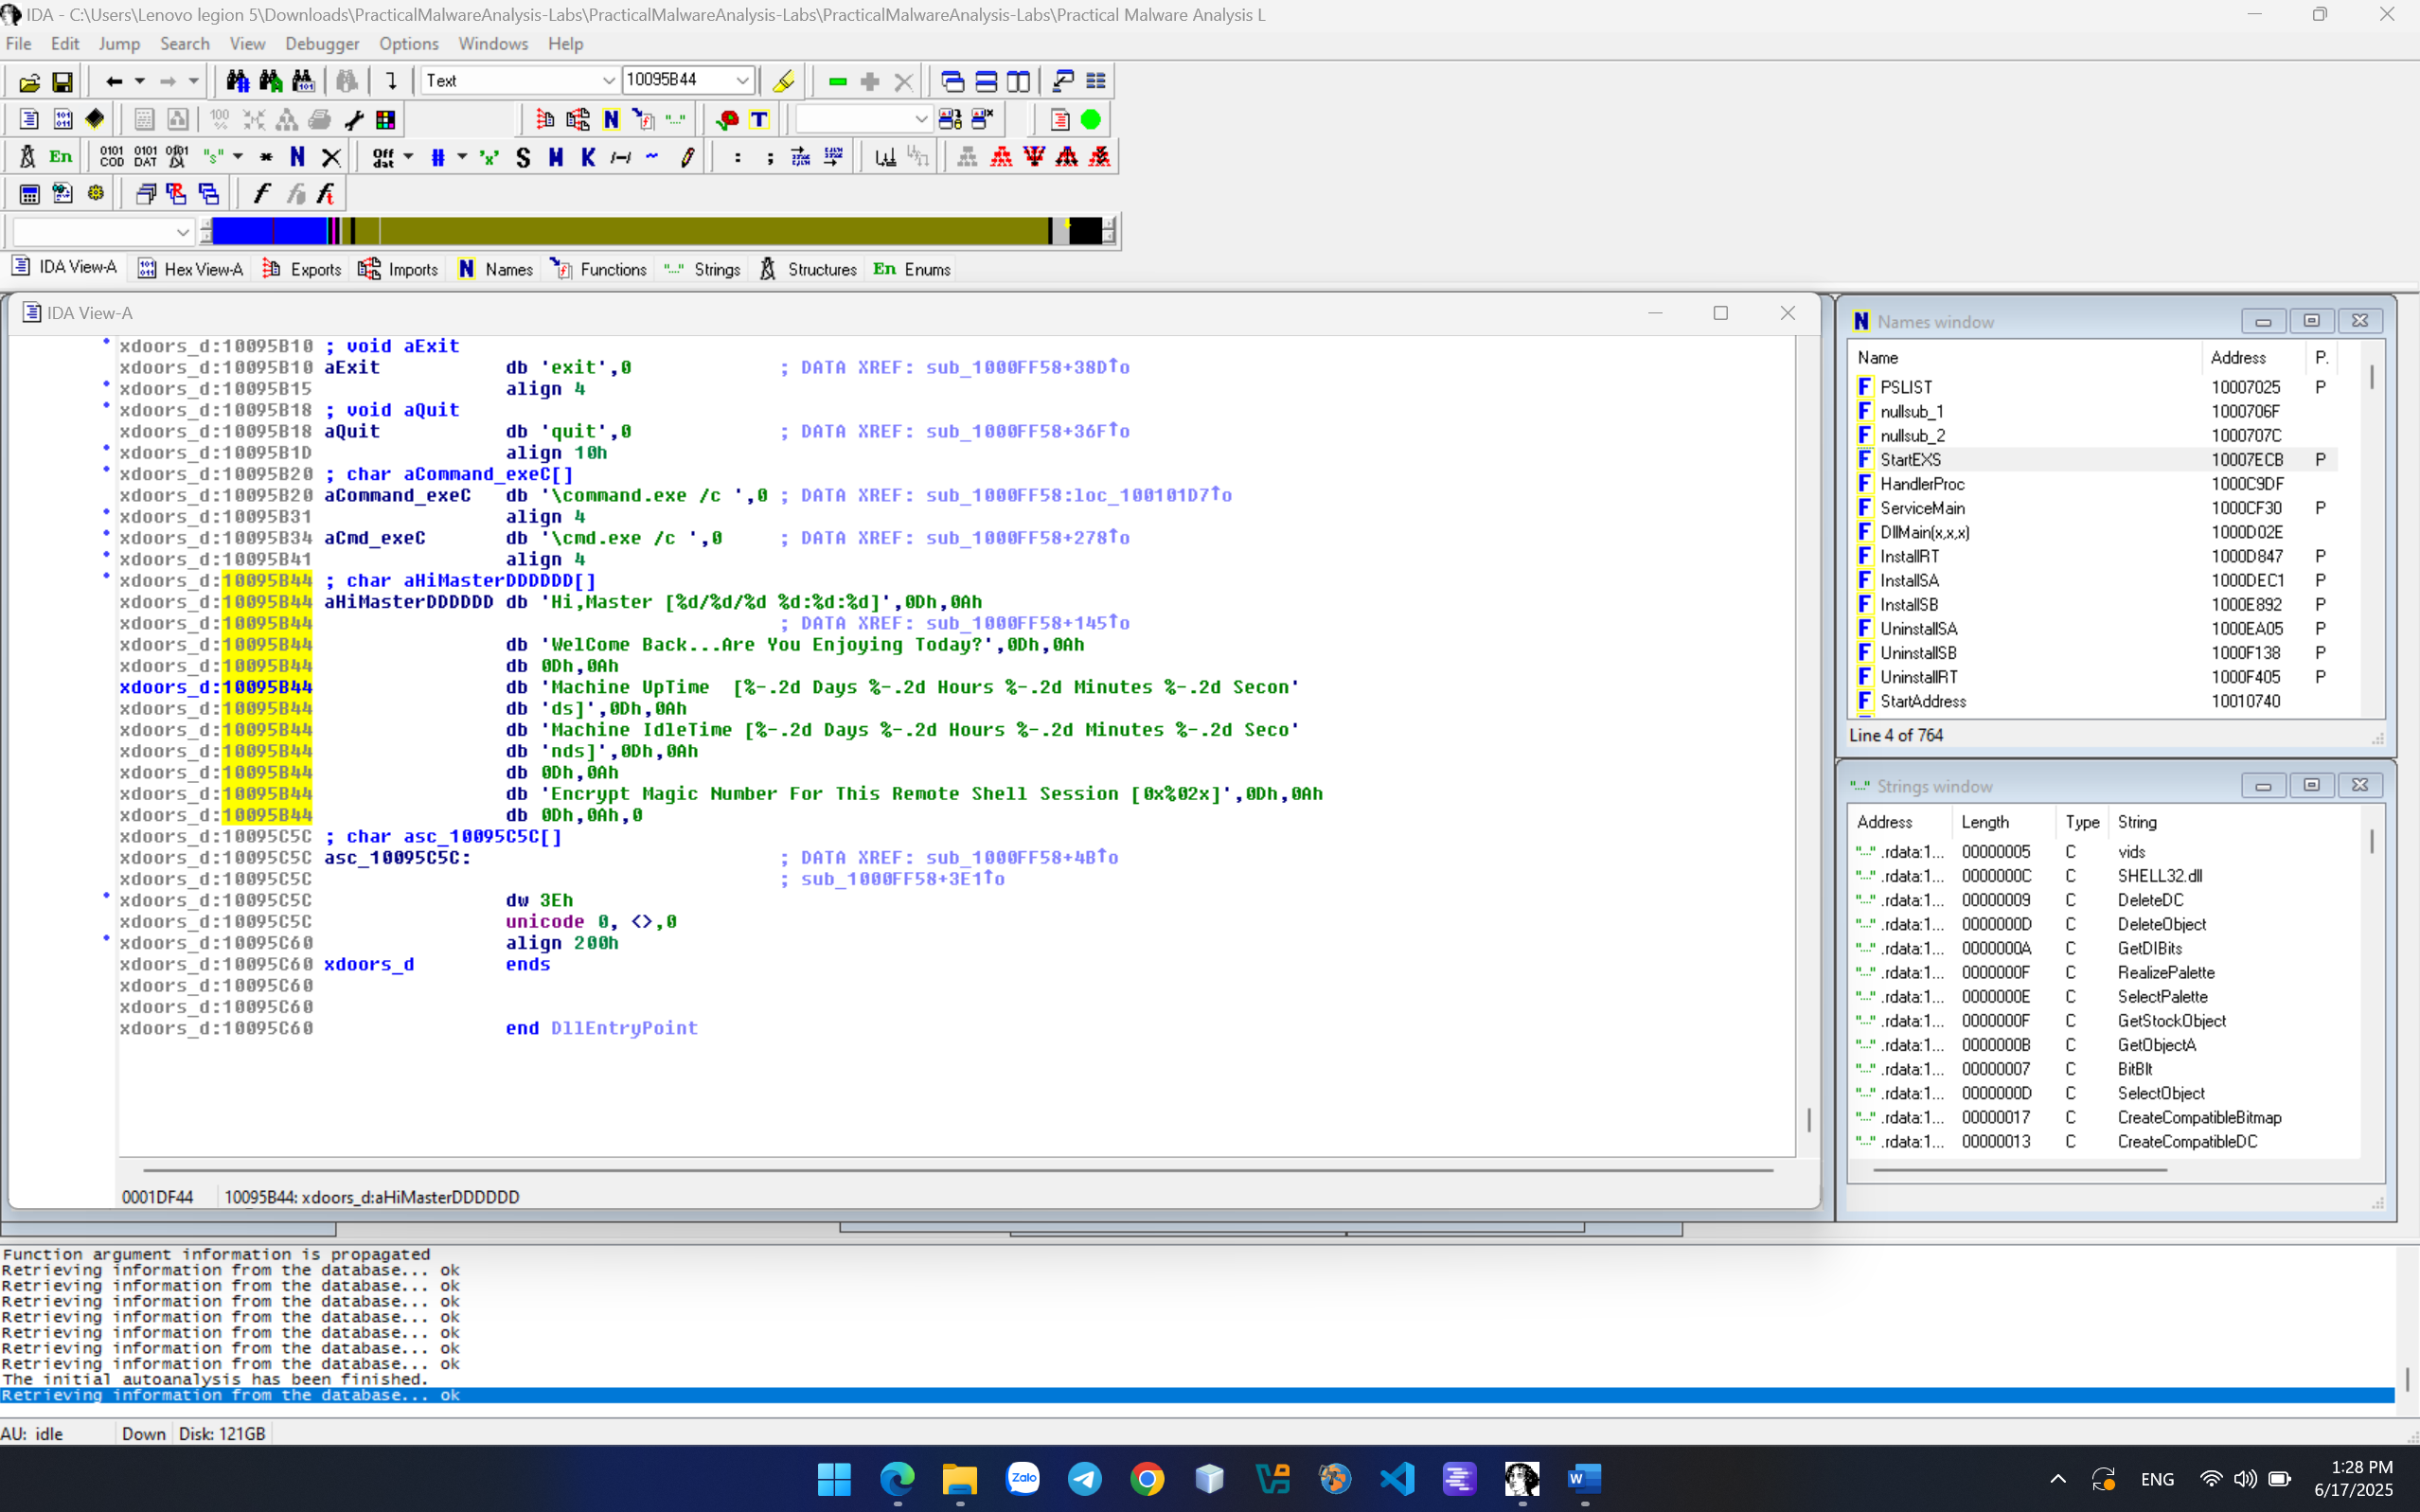

**LAB 9.3: Disassembling C on Windows**

Disassembling the EXE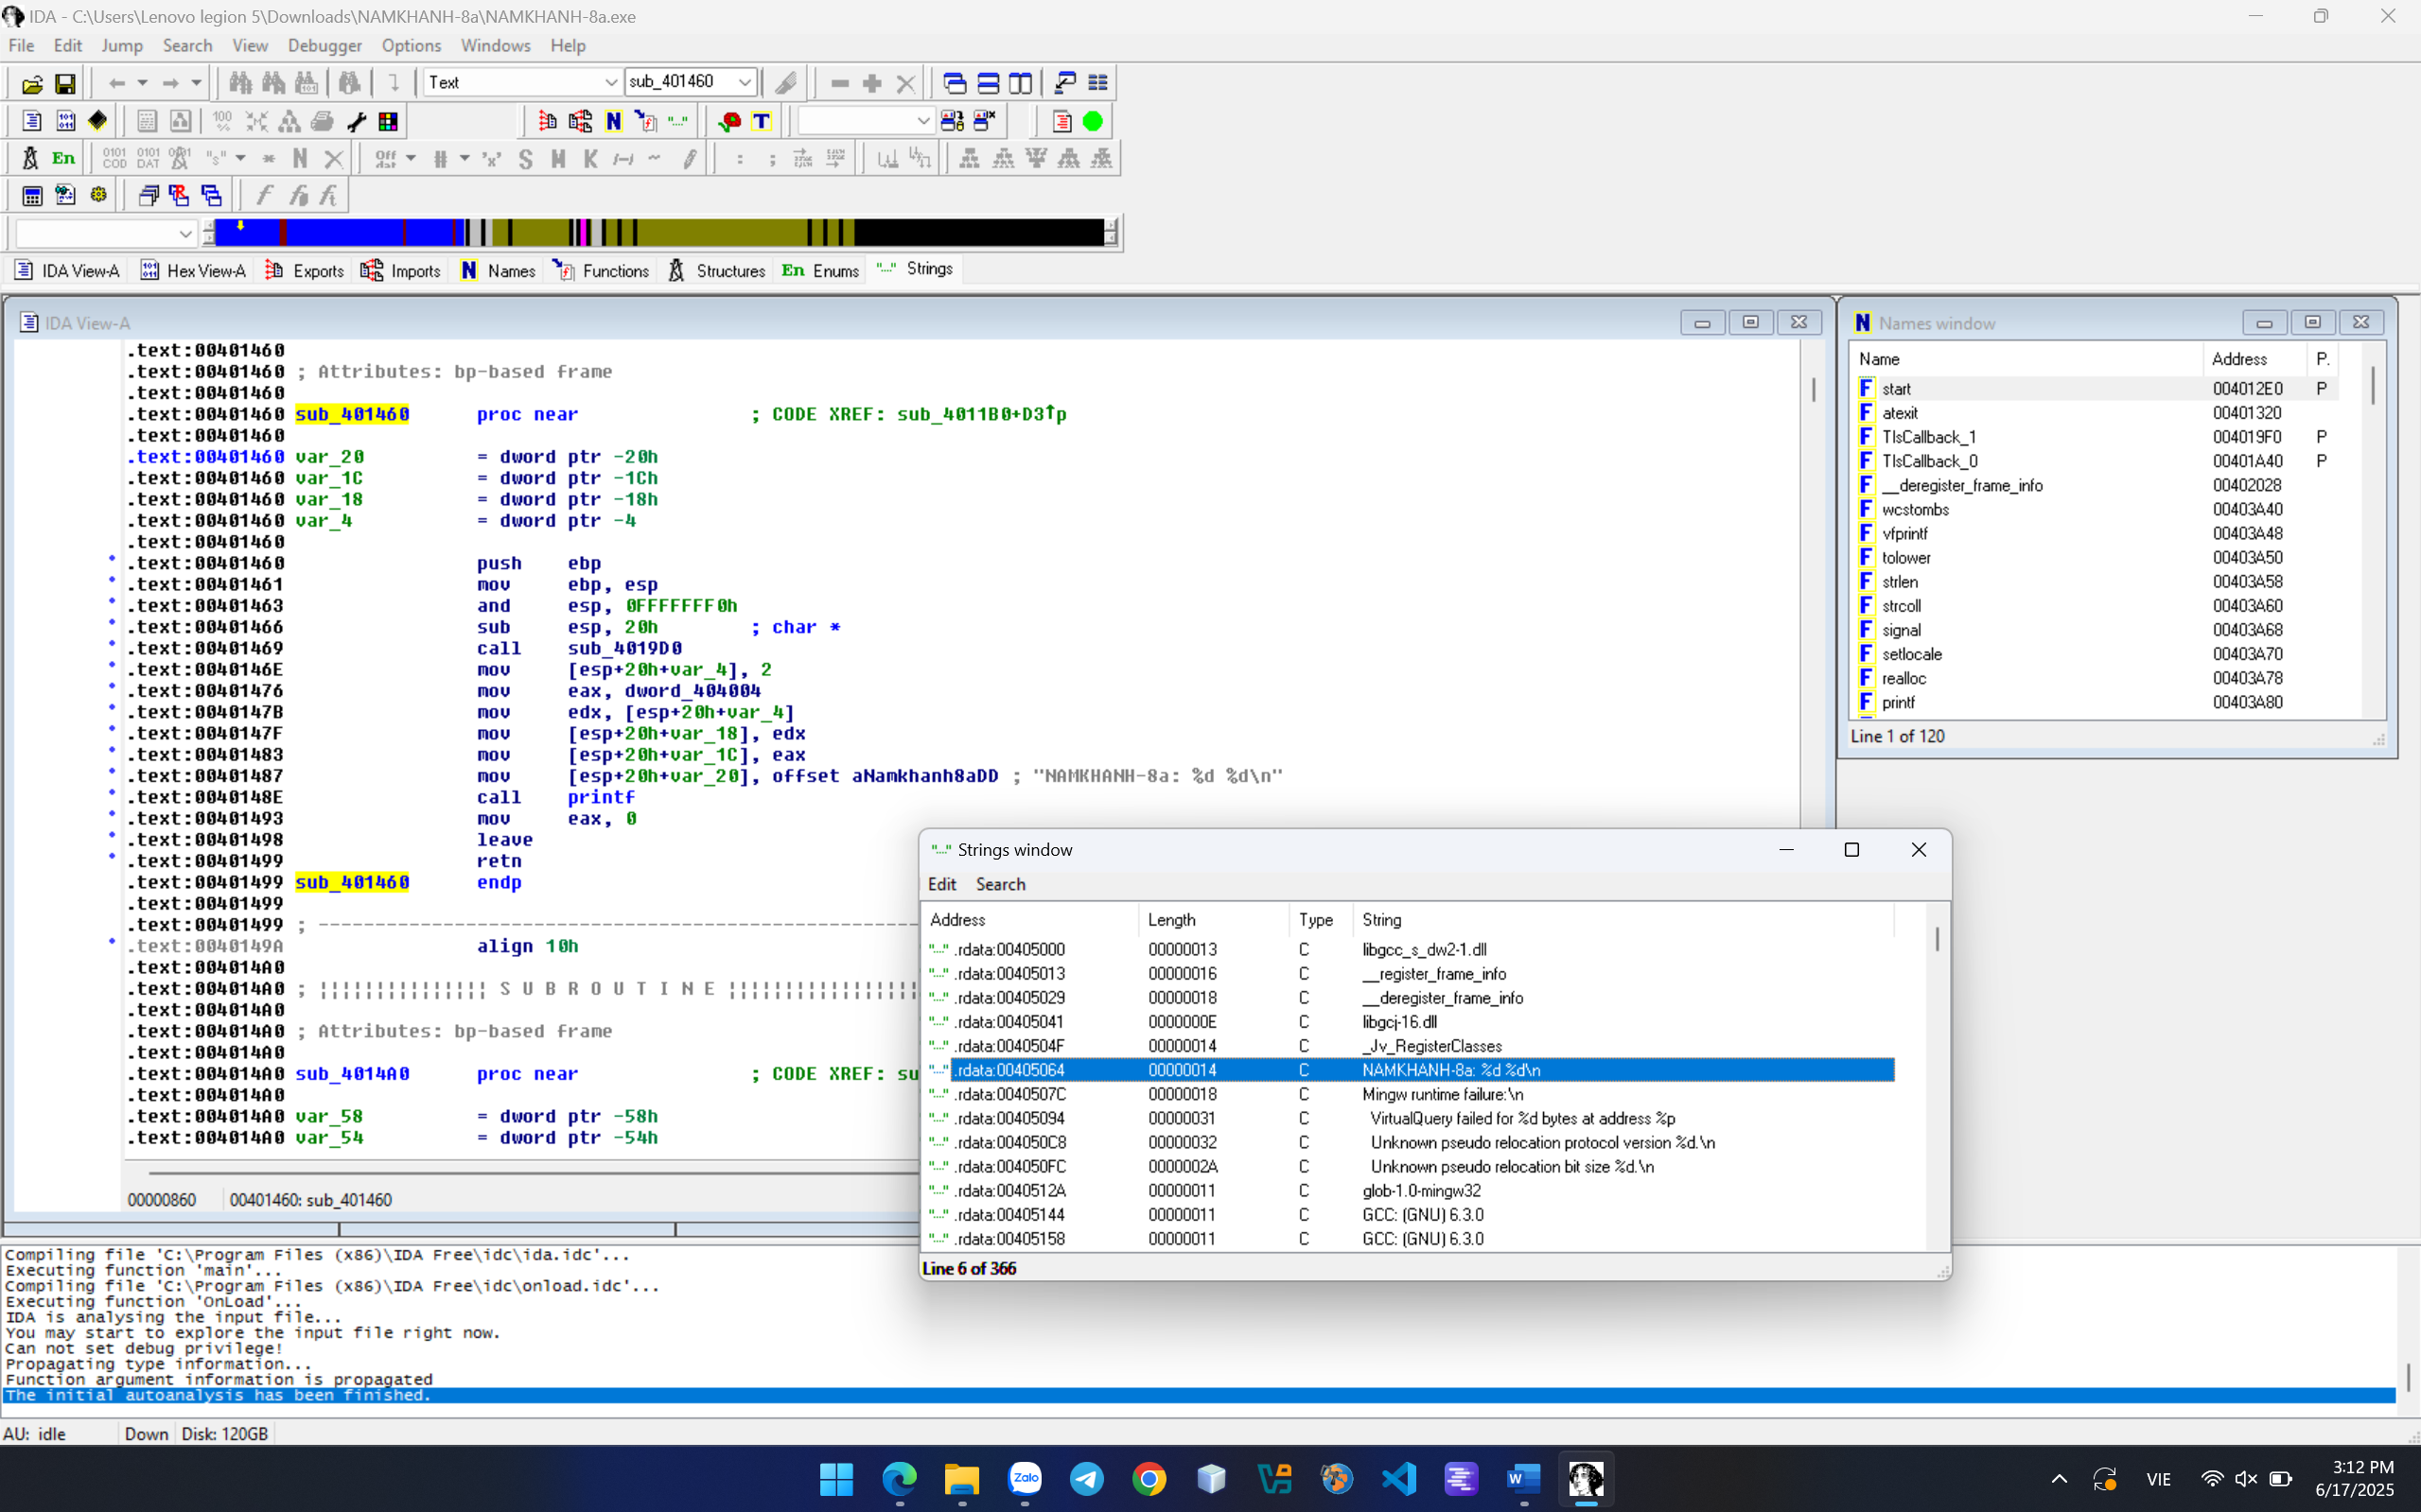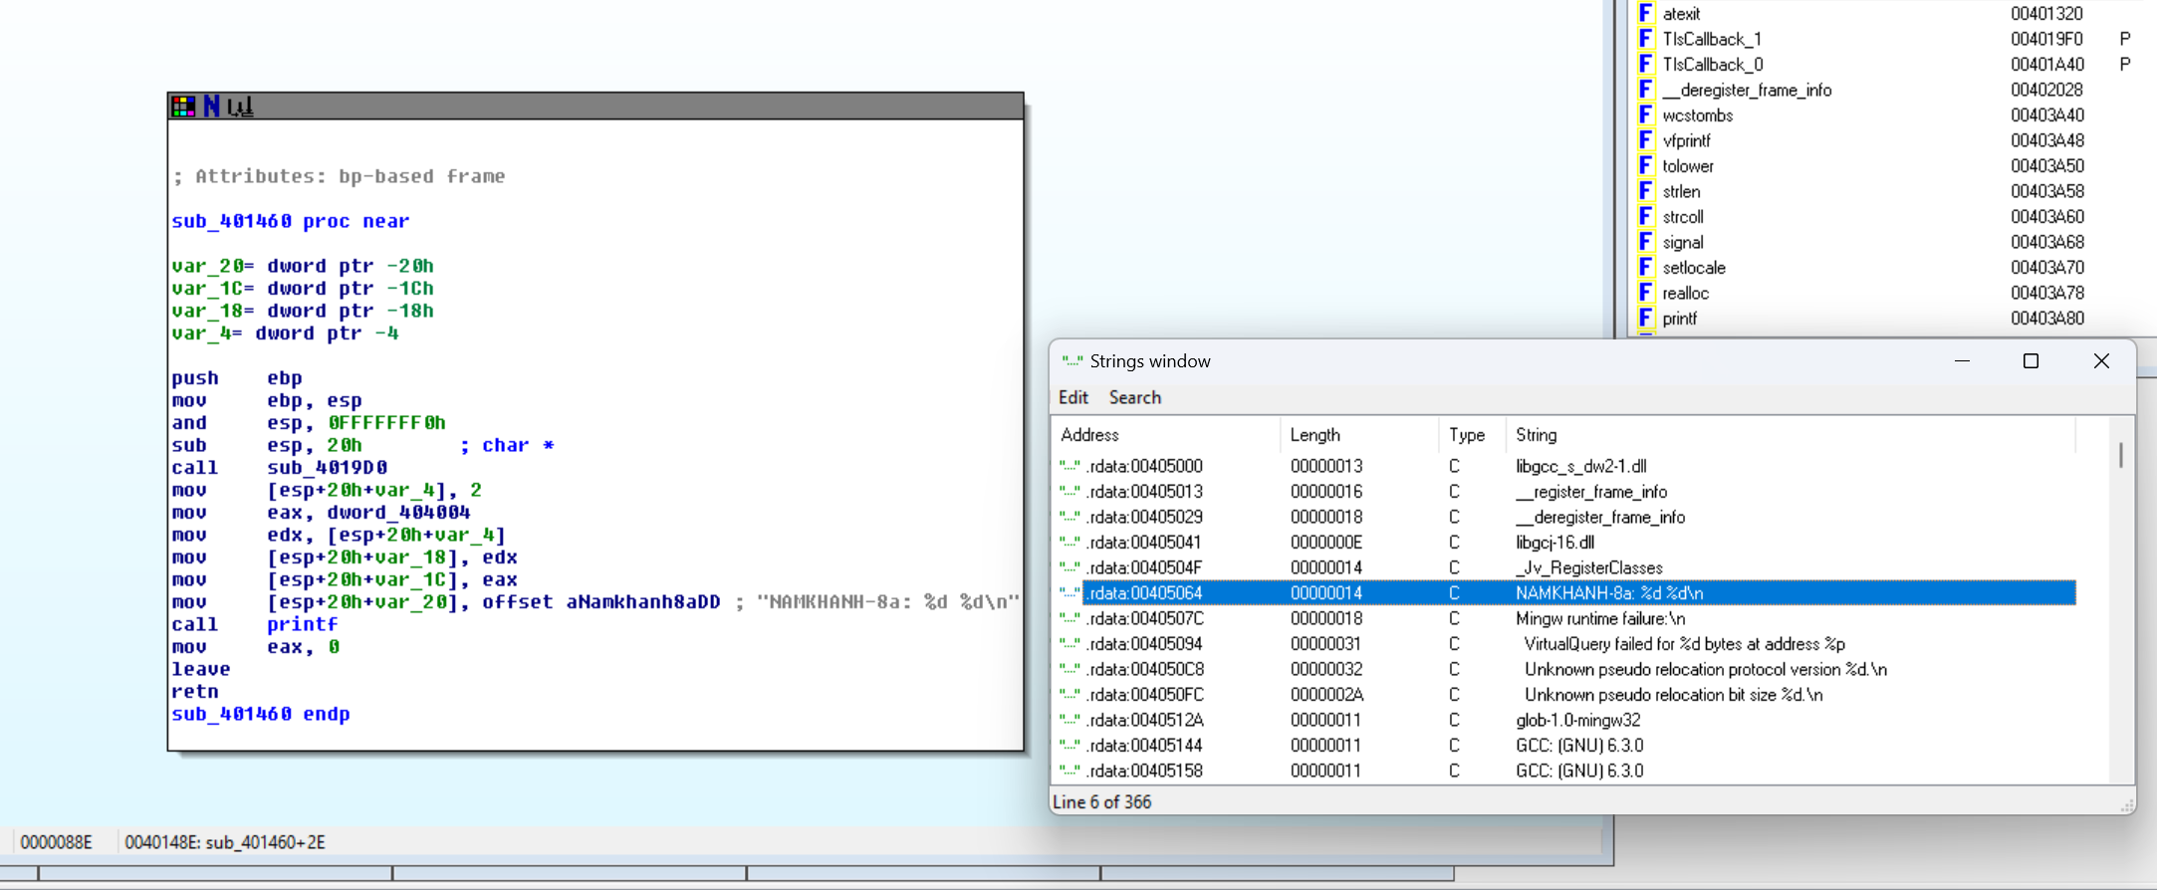

CHALLENGE:

Code: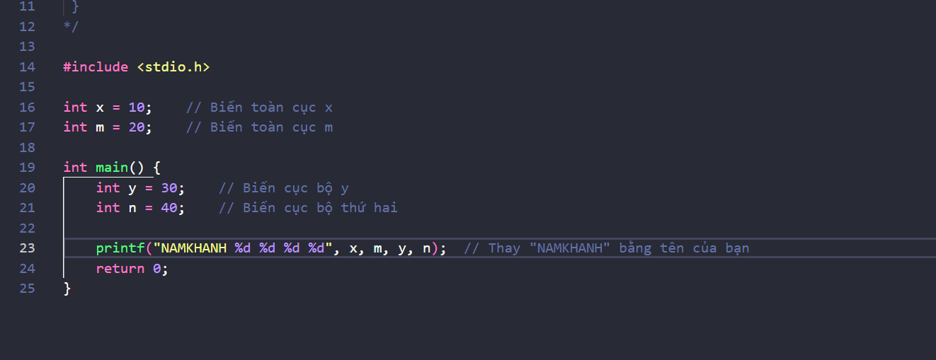 Disassembling the EXE 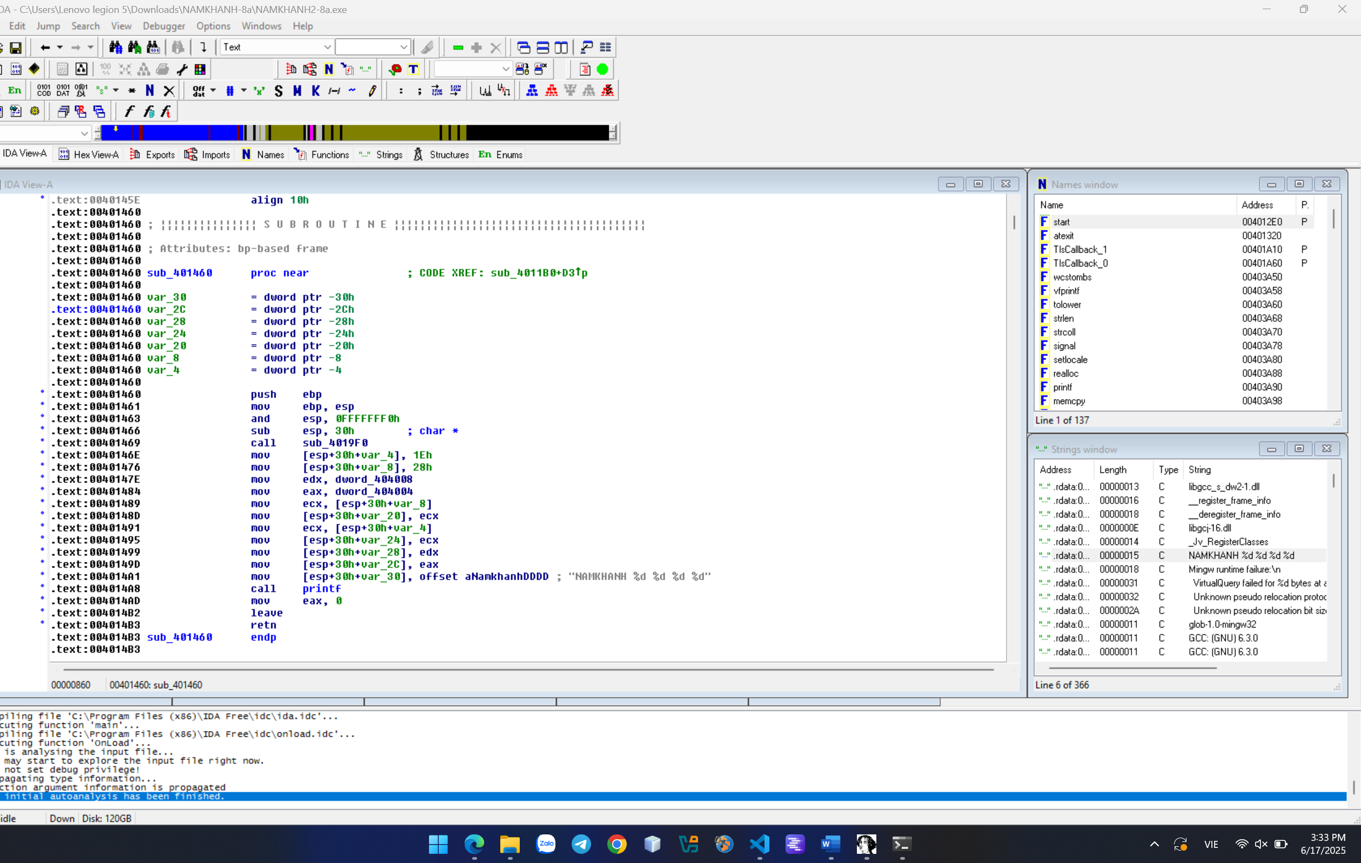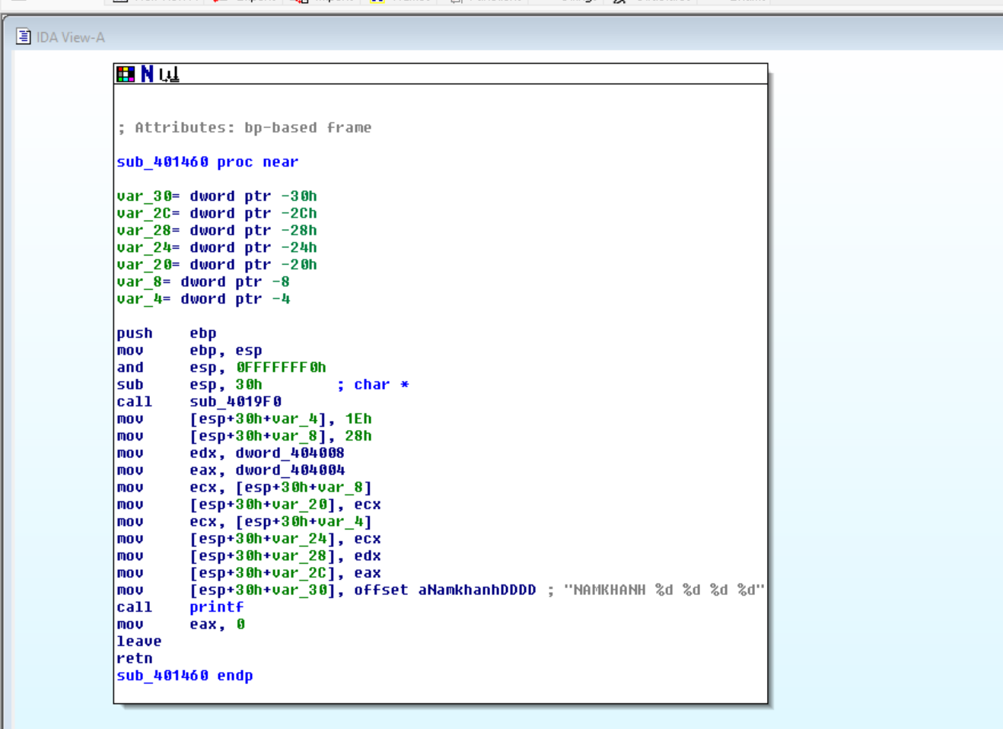

**CRACKME 8:**

This crackme is for learning how to put hardware breakpoints on memory addresses and then patch it to register the program. 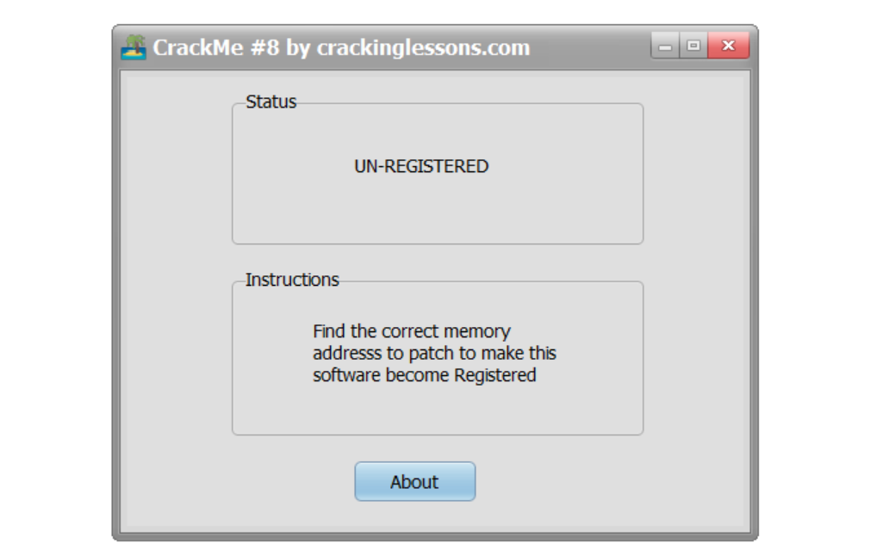

Extract the .exe file, run it for testing, and note down significant keywords. In this situation: UN-REGISTERED.

Then load the file into x32dbg, open the String references section to locate that keyword. Click on the keyword to find the corresponding code line.

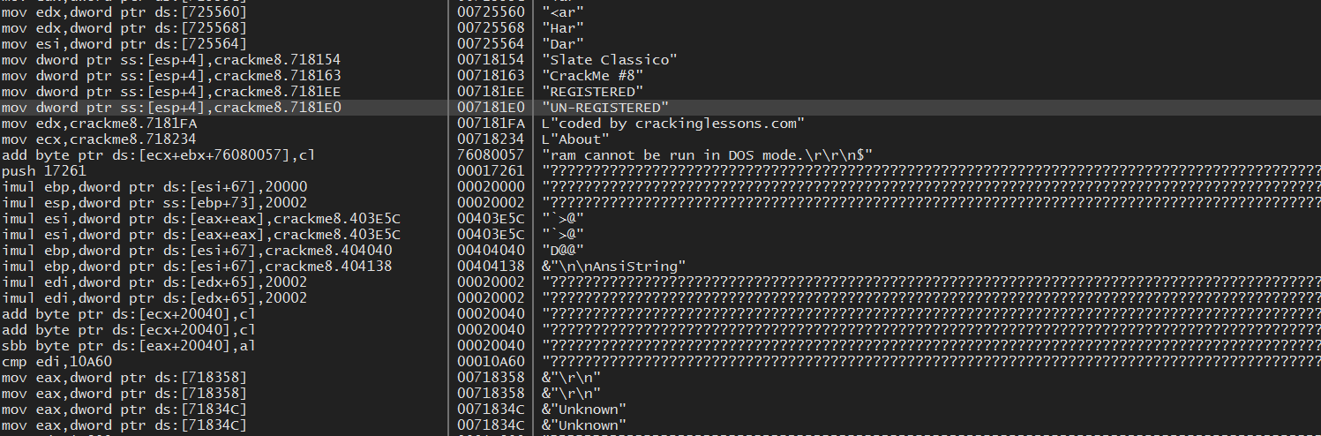

Pay attention to the code section above "UN-REGISTERED".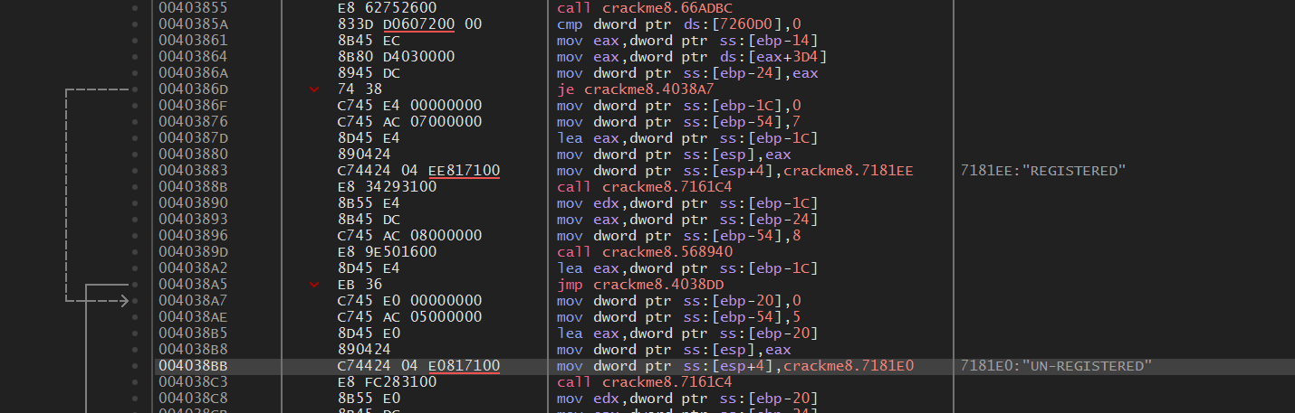

Locate the processing section that causes the program to display the "UN-REGISTERED" status. This is the code section shown below: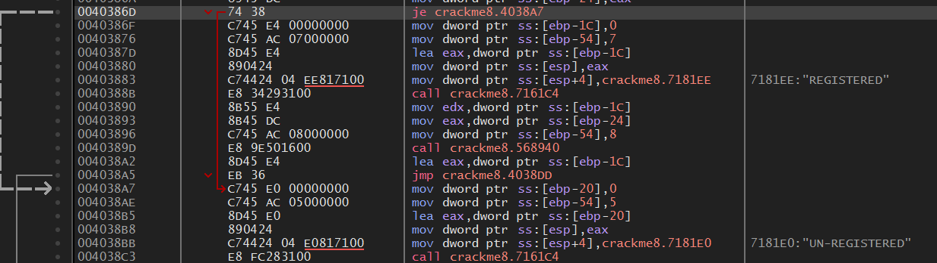

The JE instruction will jump to the "UN-REGISTERED" status processing section if the condition of the preceding CMP instruction is satisfied. Below are the details of the CMP instruction: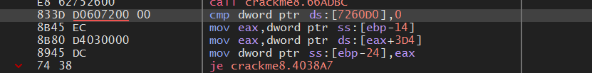

Compare the PTR DS variable with the value 0. If the condition is met, the JZ flag will be set and the JE instruction will be executed. To make the program display "REGISTERED" status instead of "UN-REGISTERED", we need to change the comparison value with the PTR DS variable to a non-zero value. Let's try changing it to 1.

Patching file and running again: 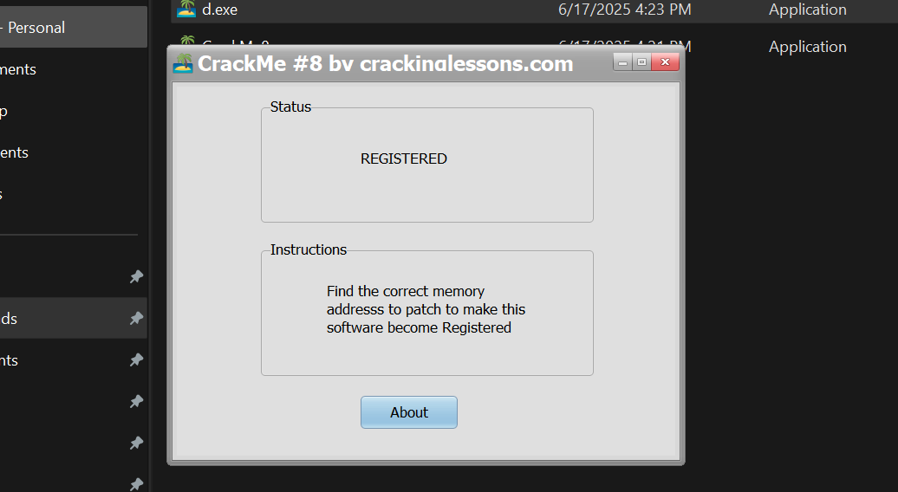

DONE!